Lecture notes of 10th Nov, 2005
Prepared by: Suresh Sharma (03CS1015)

Code Generation from a Labeled Tree:
The algorithm uses the recursive procedure gencode(n) to produce machine code evaluating the subtree of labeled tree T with root n into a register. The procedure gencode uses a stack rstack to allocate registers. Initially rstack contains all available registers. When gencode returns, it leaves the registers on rstack in the same order it found them. The resulting code computes the value of the tree T in the top register on rstack.
The function swap(rstack) interchanges the top two registers on rstack. The use of swap is to make sure that a left child and its parent are evaluated into the same register. The procedure gencode uses a stack tstack to allocate temporary memory locations.

The code-generation algorithm is to call gencode on the root of T. The gencode procedure can be explained by these cases:
Case 0: That is, n is a leaf and the leftmost child of its parent. Therefore we generate just a load instruction.
Case 1: we have a subtree of the form for which we generate code to evaluate n₁ into register R=top(rstack) followed by the instruction op name R.
Case 2: A subtree of the form where n₁ can be evaluated without stores but n₂ is harder to evaluate than n₁ as it requires more registers. For this case, swap the top two registers on rsatck, then evaluate n₂ into R=top(rstack).We remove R from rstack and evaluate n₁ into S = top(rstack). Then generate the instruction op R, S, which produce the value of n in register S. Another call to swap leaves rstack as it was when this call of gencode begins.
Case 3: It is similar to case 2 except that here the left subtree is harder and is evaluated first. There is no need to swap registers here.
Case 4: It occurs when both subtrees requires r or more registers to evaluate without stores. Since we must use a temporary memory location, we first evaluate the right subtree into the temporary T, then the left subtree, and finally the root.

Procedure gencode(n);
Begin
/* case 0 */
if n is a left leaf representing operand name and n is the leftmost child of its parent then
print ‘MOV’ || name || ‘.’ || top(rstack)
else if n is an interior node with operator op, left child n₁, and right child n₂ then
/* case 1 */
if label(n₂) = 0 then begin
let name be the operand represented by n_{2;}
gencode(n₁);
print op || name || ‘.’ || top(rsatck)
end
/* case 2 */
else if 1 ≤ label (n₁) < label(n₂) and label(n₁) < r then begin
swap(rsatck);
gencode(n₂ );
R := pop(rstack); /* n₂ was evaluated into register R */
gencode(n₁);
print op || R || ‘.’ || top(rstack);
push(rstack,R);
swap(rstack)
end
/* case 3 */
else if 1 ≤ label (n₂) < label(n₁) and label(n₂) < r then begin
gencode(n₁);
R := pop(rstack); /* n₁ was evaluated into register R */
gencode(n₂);
print op || R || ‘.’ || top(rstack);
push(rstack,R);
end
/* case 4, both labels ≥ r, the total number of registers */
else begin
gencode(n₂ );
T := pop(tstack);
Print ‘MOV’ || top(rstack) || ‘.’ || T;
gencode(n₁);
push(rstack,R);
print op || T || ‘.’ || top(rstack)
end
end

Example:

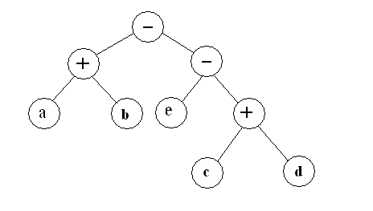
The code for the labled tree shown in Fig with rstack = R0 , R1 initially. The sequence of calls to gencode and code printing steps are given as:

gencode(t₄)
gencode(t₃)
gencode(e)
print MOV e, R1
gencode(t₂)
gencode(c)
print MOV c, R0
print SUB r0, R1
gencode(t₁)
gencode(a)
print MOV a, R0
print ADD b, R0
print SUB R1, R0

