Graphemic and Phonemic Networks (Project 3)

Brief Description: - To Build and analyze the network where each word is a node. There is an edge between every two nodes of the network with edge-weight being the edit-distance between the words (both graphemic and phonemic). Each node also has a weight equal to its usage frequency.

Motivation – The results of this experiment can have many useful applications. For example, after studying the confusion probability of different words in languages like English, Hindi and Bengali we can tell which words are more frequently confused and thus need to be given special attention in building applications for Speech Recognition and Optical Character Recognition (OCR). Also, we can study the evolutionary aspects of these languages using these two networks and comment on any similarity or dissimilarity in these aspects among these languages. For example, a popular theory states that in all the languages there is a core which was present since its beginning and around which a peripheral area of words evolves with time. We can comment on the validity of this theory based on the experimental results obtained.

Network Modeling: - While representing the word list and the relation among them as a graph, we kept an adjustable parameter – Edit Distance Threshold. It is the upper limit on the edit distance between two words for their corresponding nodes to have an edge between them.

Data Description: - The word lists along with frequencies were already available for Hindi and Bengali languages. The data for the English language is taken from the URL : http://www.audiencedialogue.org/susteng.html. It is a word list, along with frequencies, of the 15,000 commonest words taken from the British National Corpus (BNC): a count of 100 million words.

However, for each language- English, Bengali and Hindi, we have considered only top 10000 words (frequency wise) so far. The words in Hindi and Bengali were first encoded to kgpiscii format.

Initial Conclusions-

1. Consider the plots Degree Vs Occurrence Frequency for threshold = 3 for all 3 languages. It is noticed that most of the very high frequency words have large degree and thus higher confusion probability. This is also verified by looking at the top 10 words, highest degree wise, in each language.

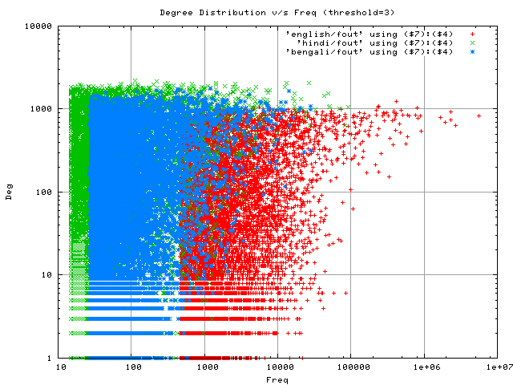

We plotted the degree distribution curves for these three languages while varying the two parameters - Edit Distance Threshold and Interval. Interval is used while plotting the curve and is used to club the nodes in intervals. For example if interval = 10 then nodes with degree 0-9, 10-19,….are shown as a single point over the curve. The observations are-

2. If we increase the Edit Distance Threshold to 8, the graph almost becomes fully connected (for all three languages). This means that almost all the words in these languages are within edit-distance (graphemic) 8 from each other.

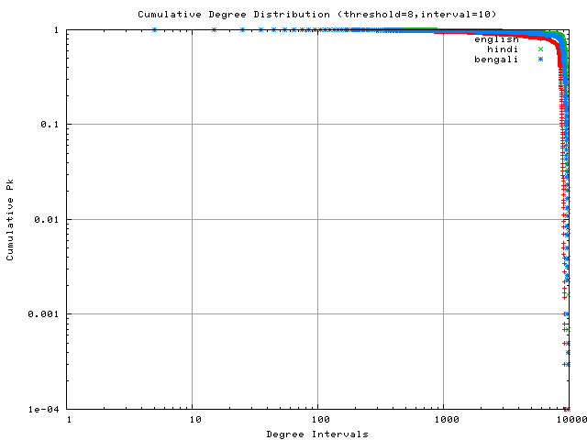

3. Considering the general nature of words and languages, we can say that

Edit Distance Threshold should not be set above 3 since two words with edit-distance ≥ 4 have almost nothing in common both in spoken and written English. Thus we mainly analyze the degree distribution curves with threshold ≤ 3. Consider the following plot with threshold=3. We observe that plot for each language actually comprises of 2 line segments

